***Nama : Jihad Rafsanjani  
Keterangan : Tugas Modul 7.1 Visualization with tableau***

Dasboard page Home

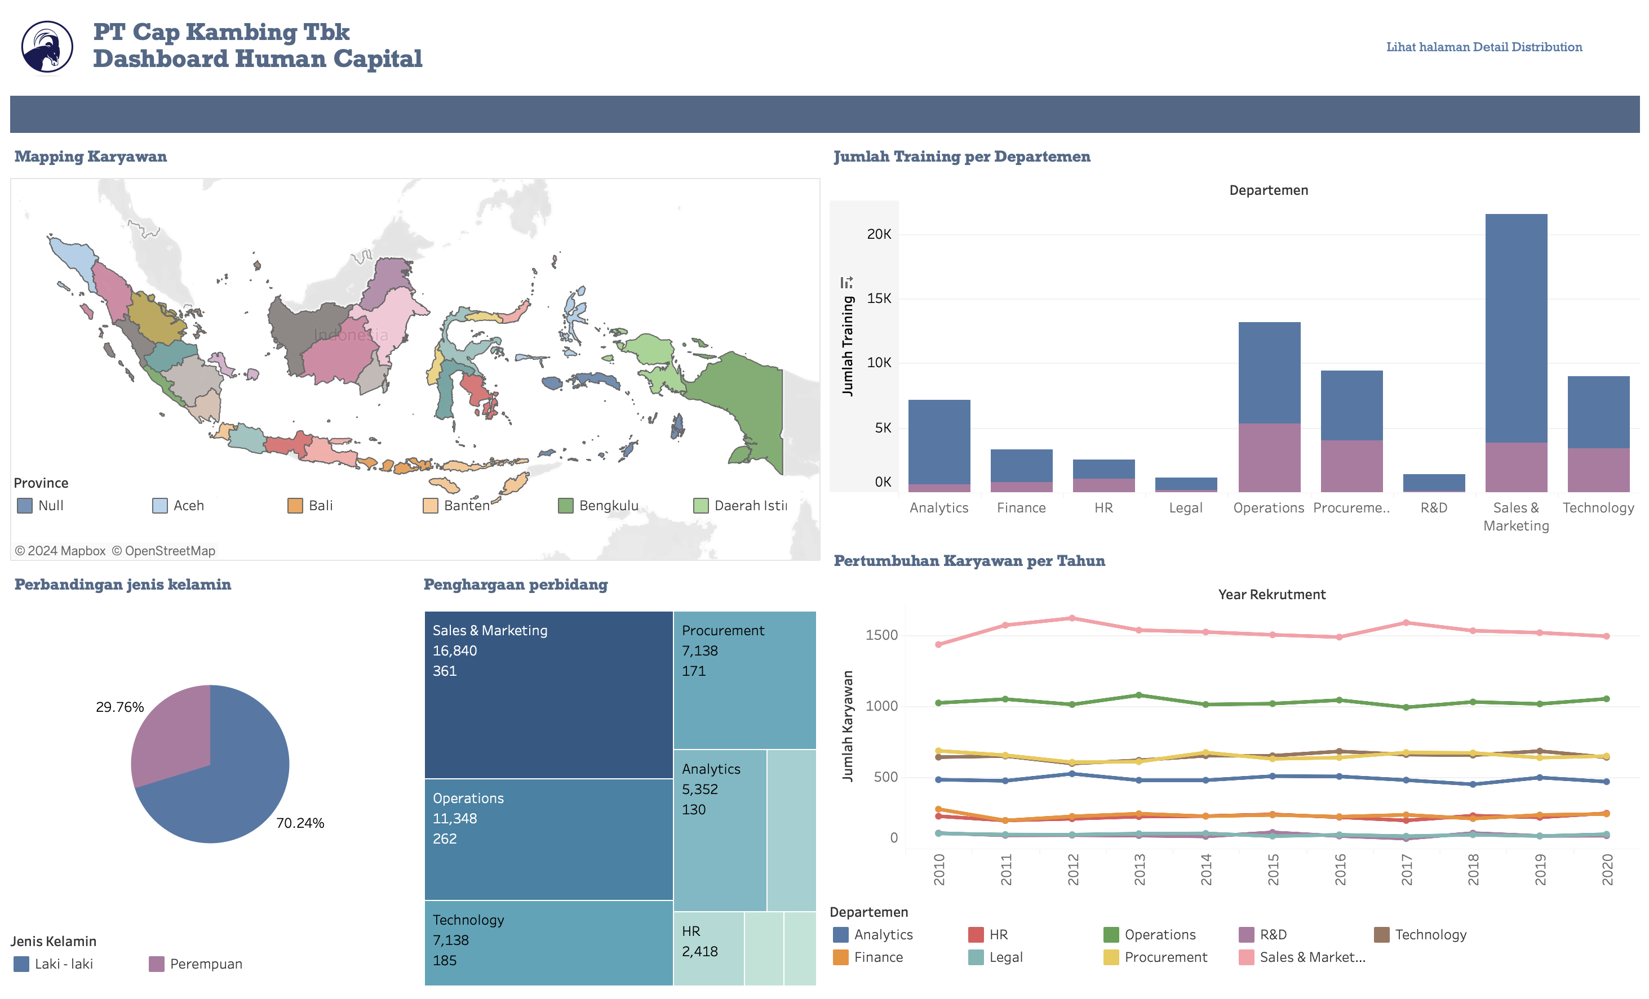

Dashboard Page Detail Distribution Employee

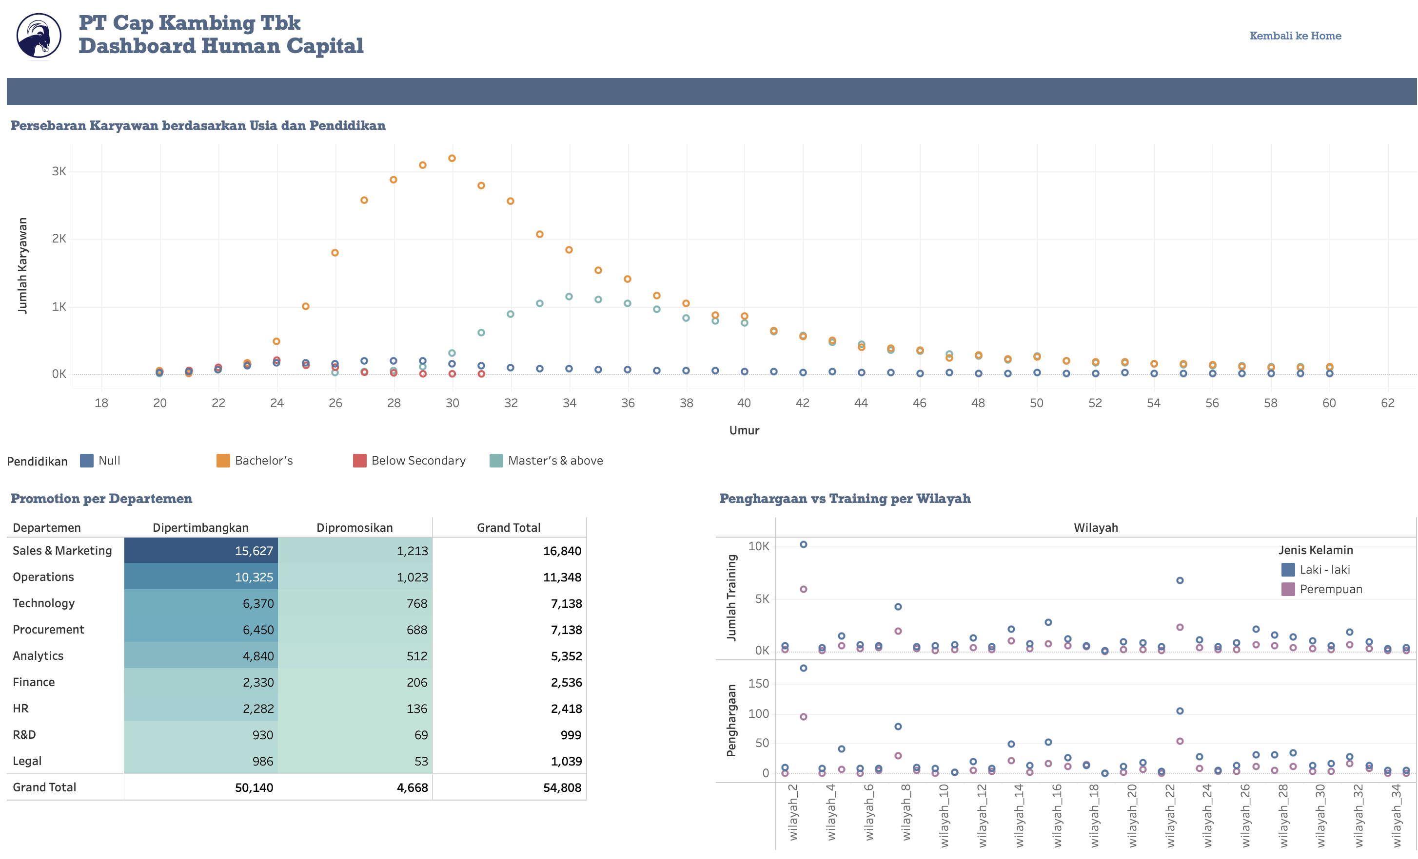

Link Dashboard : <https://public.tableau.com/views/Tugasmodul7/Home?:language=en-GB&publish=yes&:sid=&:redirect=auth&:display_count=n&:origin=viz_share_link>

Link Story : <https://public.tableau.com/views/Tugasmodul7/Persebarankaryawan?:language=en-GB&publish=yes&:sid=&:redirect=auth&:display_count=n&:origin=viz_share_link>